1. 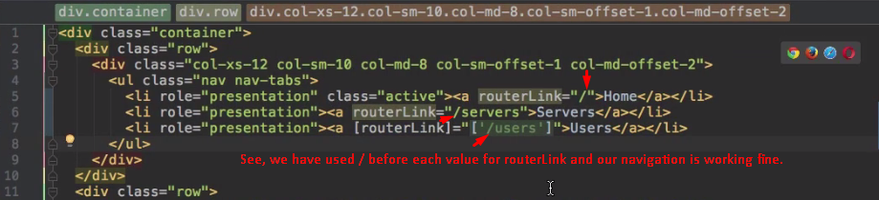
2. 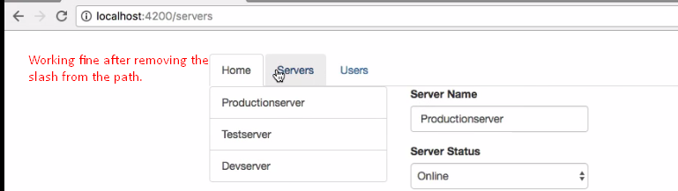
3. 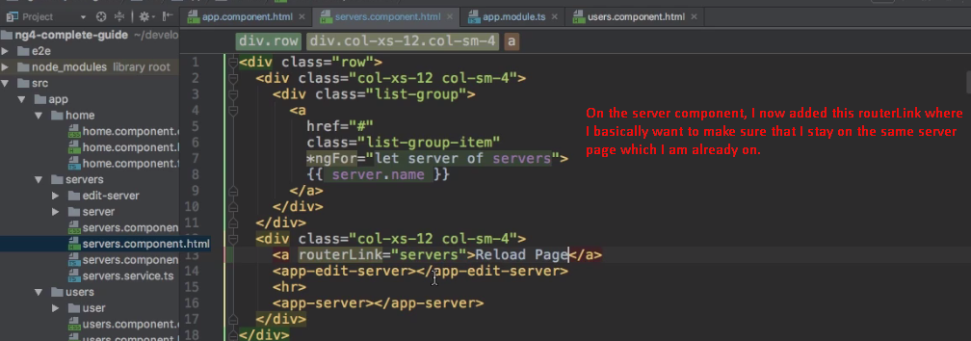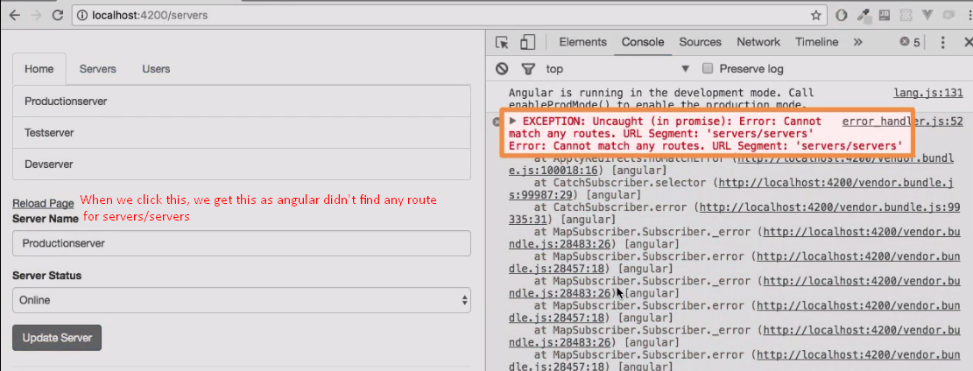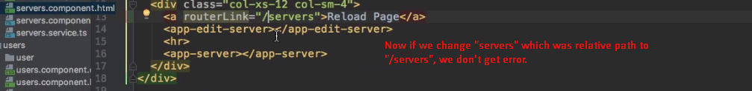
4. 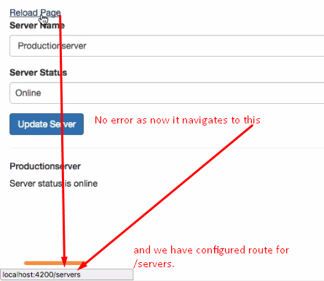
5. 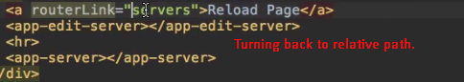
6. 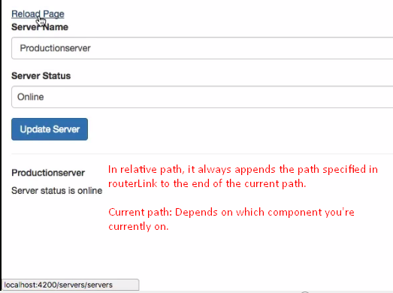
7. Root component is not loaded by a router so we sit at localhost:4200/. So the relative path is /.  
   So we can use relative path “servers” or absolute path “/servers” which will resolve to “/servers” and this path is configured in our route configuration.  
   **NOTE**: Relative path can be helpful in case of nested component.
8. **Other forms of giving path**:
   1. **routerLink=”./servers”🡸** Relative path
   2. **routerLink=”servers”🡸Relative Path 🡸 We discussed above**
   3. **routerLink=”../servers”🡸**Go one directory up.